Name : Shija R
Reg No : 411625149042
Department : BE CSE WITH CYBER SECURITY
Subject : Python
Batch : 1

Mini Project 1:ATM System using Python

1. Project Title
ATM System using Python

2. Problem Statement
To design and implement an ATM system that allows users to perform banking operations such as checking balance, withdrawing money, depositing money and exiting using a menu driven approach.

3. Objective
- To simulate basic ATM operations
- To use menu driven programming
- To understand loops and conditional statements
- To implement real-life banking logic

4. Tools Used
- Python 3
- VS Code / IDLE

5. Description
This project simulates the working of an ATM. The user can select options from the menu to check balance, deposit money, withdraw money or exit. The balance gets updated after each transaction.

6. Algorithm
- Initialize balance
- Display ATM menu
- Read user choice
- If choice is deposit → add amount
- If choice is withdraw → subtract amount
- If choice is balance → display balance
- Repeat until exit

7. Program (Python Code)
balance = 5000

while True:
print("\n----- ATM Menu -----")
print("1. Check Balance")
print("2. Deposit")
print("3. Withdraw")
print("4. Exit")

choice = int(input("Enter your choice: "))

if choice == 1:
print("Your Balance = Rs.", balance)

elif choice == 2:
amount = float(input("Enter deposit amount: "))
balance = balance + amount
print("Amount deposited successfully")

elif choice == 3:
amount = float(input("Enter withdraw amount: "))
if amount <= balance:
balance = balance - amount
print("Please collect your cash")
else:
print("Insufficient balance")

elif choice == 4:
print("Thank you for using ATM")
break

else:
print("Invalid choice")

8. Sample Output
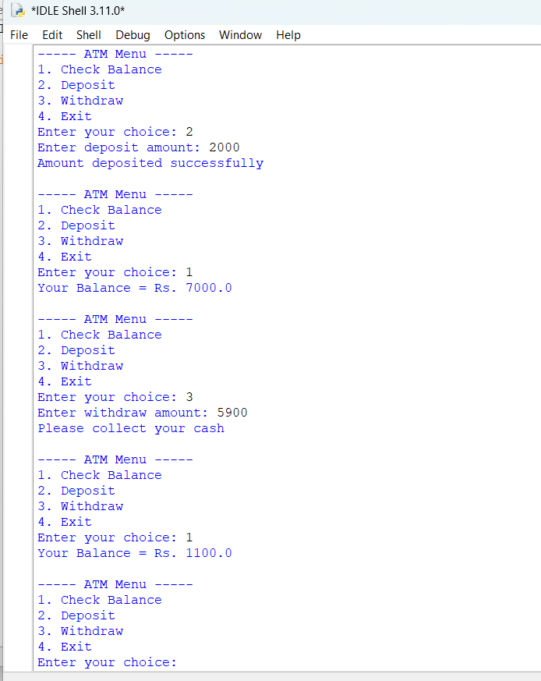
9. Result
The ATM system successfully performs deposit, withdrawal and balance enquiry operations.

10. Conclusion
This project demonstrates how Python can be used to build a simple ATM system using loops and conditions.

